Zhangye UNESCO Global Geopark Annual Report 2020

1. GEOPARK IDENTITY
Geopark name, country, regional Network: Zhangye UNESCO Global Geopark, China, Asian Pacific Geoparks Network
Year of inscription / Year of the last revalidation: 2020 / -
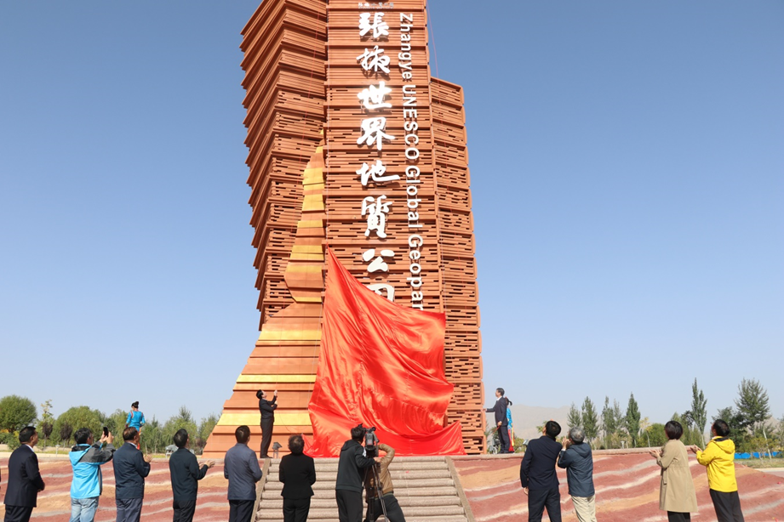
Zhangye UGGp Unveiling Monument-September 25, 2020

2. GEOPARK FIGURES
Number of Geopark staffs: 507 staffs
Number of visitors: 1.73 million.
Number of Geopark events: 36 events，22 events held by management body and 14 by cooperative organizations.
Number of school classes realize Geopark educational programmes: Kangle Mingde School is Zhangye UGGp school, and 7 classes which are total number of the school have been carried on Geopark Educational programmes regularly in the whole year.
Number of Geopark press release: 745 news which have been released on national, provincial and city media.
3. GEOPARK ACTIVITIES
Major achievements in 2020
- Zhangye UNESCO Global Geopark has joined GGN formally.
- Successfully held the Monument Unveiling Ceremony of Zhangye UGGp and Zhangye Branch, Nature & Culture Institute of Chinese University of Geosciences, Beijing.
- Successfully held the Zhangye UGGp Innovation & Development Forum.
- Actively carried out Danxia Landform legislative protection work, preliminary investigation of Danxia Landform has been accomplished and legislative regulation has been drafted,
- Elaborately compiled the Zhangye UGGp Tour Routes Guide.
- Established sister-geopark relationship with 7 geoparks.
- Produced a micro-film of Zhangye UGGp.
Contribution towards GGN - Networking and participation
- Attended the Digital Course on UNESCO Global Geoparks 2020.
- Attended the Welcome Digital Event for the New Geoparks.
- Attended 2020 Chinese UNESCO Global Geoparks Annual Conference and made a new member introduction.
- Attended the 6th International Training Course on UNESCO Global Geoparks Mangement and Development and made a case analysis report.
- Established sister-geopark relationship with Shilin, Dali Cangshan, Lushan, Alxa Desert UGGps and Longyan, Linxia, Kanbula geoparks.
- Fulfilled GGN 2020 Annual fee.
Management and Financial Status
- The Administration for Zhangye National Geopark is the management body of Zhangye UGGp, the Administration made corresponding arrangement earlier before each tourism peak after the quarantine in 2020, due to the COVID-19, Zhangye UGGp received 1.73 million visitors in the year.
- The 2020 tourism revenue in Zhangye UGGp is 235 million yuan, the Administration invested 3.7 million yuan on geoheritage protection and 650 000 yuan on scientific research and popularization activities.
Geoconservation
- Zhangye National Geopark Administration carried out regular investigation on geoheritage protection.
- Zhangye National Geopark Administration signed Geoheritage Protection Agreement with three operating companies at the beginning of the year; each operating company arranged its own geoheritage patrolling and protection work.
- Zhangye National Geopark Administration has started the geoheritage legislative protection work, after Danxia Landform investigation and a series of forums have been carried out, drafted the legislative regulation.
- Zhangye National Geopark Administration has established geoheritage protection system, target responsibility management system and natural disaster emergency plan system.
- Carried out maintenance and updating work to the aging and decaying public infrastructure.
- Updating the interpretation boards and logo system after Zhangye UGGp received the formal inscription.
Sustainable tourism (Geotourism)
- 4 visitor centers and complemented infrastructures such as parking lot, visitor squares, plank ways, and toilets have been established.
- Built the intelligent management system by setting 320 and more monitoring cameras to monitor the geoheritage and tourists safety in the geopark, which efficiently improved the ability of scientific management and risk alert and prevent.
- Compiled the Zhangye UGGp Tour Routes Guide.
- Guided the operating company to establish Danxia Tour Agency and develop tourism products.
New education programmes on geoconservation, sustainable development and disaster risk reduction
- Started Geoheritage Protection Facility Construction Project.
- Carried out geo-disaster risk prevention work, investigated and sorted out the geo-disaster risks in the geopark.
- Urge the operating company to accomplish projects registration, geo-disaster assessment report, practicability study report and overall projects planning.
- Started the Zhangye UGGp Kangle Geo & Culture Village Project.
- Compiled and improved Zhanye UGGp Plan.
Strategic partnership
- Deepened the cooperation between Zhangye UGGp and China University of Geosciences (Beijing), and Zhangye Branch, Nature & Culture Institute, China University of Geosciences (Beijing) has been established in the geopark.
- Deepened the cooperation between Zhangye UGGp and Xi’an Center, China Geological Survey, and started the new project of Kangle Geo & Culture Village.
Promotional activities
- Put on the stage play Memory of Zhangye regularly to strengthen tourism attraction.
- Attended the Welcome Digital Events for the New Geoparks and promote on local and geopark websites, wechat public accounts.
- Held press conference on Information Office of Gansu Provincial Government, formally released the news of Zhangye UGGp inscription, promoted Zhangye UGGp both online and off line.
- Held the 2nd Balloon Festival in Zhangye UGGp.
- Held the Monument Unveiling Ceremony of Zhangye UGGp.

4. CONTACTS
Manager: ZHU Pengxian 943428316@qq.com
Geologist: YIN Zheng 549619616@qq.com

